horizontal line

**Brodie Armstrong**

**Beth Emborsky**

Flu Influences by Weather

**25th June 2020**

# Relationship Between ILI Cases and Temperature

It is clear that temperature has an impact on how many cases of influenza-like illness (ILI) were diagnosed in every major city (by population) in the U.S. that we examined. Each year as the average temperatures started to get colder in the winter months, the number of reported flu cases increased. Here is an example of 2 of the cities showing this relationship:

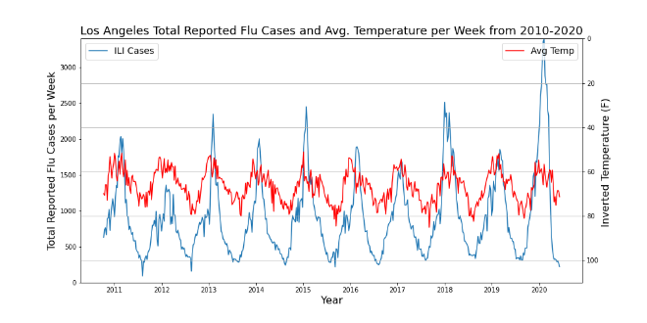

# Relationship Between ILI Cases and Precipitation Totals

Unlike temperature, precipitation totals did not show any trend associated with cases of influenza-like illness in every major city (by population) in the U.S. that we examined. Here is an example of 2 of the cities showing this relationship:

# Relationship Between Total Positive Flu Tests and Temperature

It is clear that temperature has an impact on how many cases of influenza-like illness (ILI) were diagnosed in every major city (by population) in the U.S. that we examined. Each year as the average temperatures started to get colder in the winter months, the number of reported flu cases increased. Here is an example of 2 of the cities showing this relationship: